**Guidelines for Developing Video Courses**

**ABOUT US**

**Beijing Foreign Studies University, or BFSU**, is one of China’s top universities under the direct leadership of the Chinese Ministry of Education. It is listed under Project 985, Project 211 and Double First-Class Project of China. BFSU has, since 1941, produced a large number of qualified professionals who, after graduation, work in and outside China as diplomats, translators/interpreters, educators, businessmen/women, journalists, lawyers, bankers, etc. Among BFSU alumni, over 400 have worked as ambassadors, and over 2,000 as counselors. BFSU is thus known as “a cradle for diplomats”.

**International Business School, or IBS**, founded in 2001, is the most dynamic school at BFSU, the largest in terms of student number, and the most internationalized business school in China, with 1200 Chinese students and 600 international students from over 80 countries studying together. From Australia to the United States, Japan to South Africa, Finland to Chile, we have partnered with over 400 universities, research institutes, and international organizations in 88 countries and regions.

**Research Center for the Internationalization of Companies from Emerging Economies, or I-CEE Center**, was initiated by IBS.BFSU, jointly with SolBridge International School of Business, Woosong University, and in collaboration with other international partners. in collaboration with our international partners. Since the 1990’s, Foreign Direct Investment by MNEs based in emerging economies has increased significantly. Their internationalization path is quite different from their counterparts based in developed economies, also met with unique opportunities and challenges. Research in this area is far from sufficient, requiring more commitment and contribution from the intellectual institutions. Based on extensive cooperation with scholars from all over the world, I-CEE Center strives to encourage and support the research on the international business of MNEs from emerging economies, aiming to help companies and policymakers to better understand this topic, therefore succeed in developing and carrying out the internationalization strategies.

**VIDEO COURSES**

In order to enrich our course offering, providing access to the best quality learning resources of special business courses about national and regional study across the world, the program of ‘BFSU Solbridge Study Web’ is launched.

We are inviting international scholars to join this program to help develop video courses in the following two categories.

1. **International Business: Regional Topics**

It refers to the course introducing business in the context of a target region or country. You may refer to the following sample courses.

Optional Topics: Politics, Culture, Law, Economics, Management, etc.

Sample Courses: The Government and Politics in Vietnam;

Chinese Culture and Business Etiquette;

Malaysian Business Law;

E-commerce in China;

Doing Business in Russia;

Marketing in Thailand;

Strategic Management in EU;

Foreign Trade of South Korea;

Foreign Direct Investment in Indonesia

1. **Specialized Business Courses**

The specialized business courses targeting Junior, Senior Undergraduate and Graduate.

**PROPOSAL AND ACCEPTION**

1. Please fill in and submit the **Proposal** for video course (Attachment 1) to [IceeCenter@gmail.com](mailto:IceeCenter@gmail.com).
2. On receipt of the Proposal, the program committee shall convey its approval, amendment suggestion or rejection within three weeks. An online interview may be conducted if necessary.
3. Once the proposal is accepted, the applicant needs to submit a **Demo video** of 10-15 minutes and wait for final approval.
4. With the final approval, the applicant shall proceed with the development of the video courses as required in the next part.
5. If the proposed course will last more than 15 hours, please send the completed part for mid-term review when half of the work is done.

**REQUIRED CONTENTS**

1. Total length of the course is flexible to be proposed. A complete course shall include many video clips, each lasting 5-20 minutes.

For International Business: Regional Topics: Applicants may choose to develop a single-topic lecture of no less than 2 hours, or a one-semester course of 20-24 hours.

For Specialized Business Courses: 20-24 hours for most regular one-semester courses, and longer hours acceptable for some special courses.

1. Self-introduction video of less than 5 minutes, including but not limited to your name, nationality, institution, contact info, and research area. Please separate the self-introduction video from the course video.
2. Syllabus as per the template to be provided after the acceptance of the proposal.
3. Corresponding PowerPoint slides, with either of the following IBS.BFSU logo at the bottom left. Please don’t include any other institution name or logo in the PPT or the video.

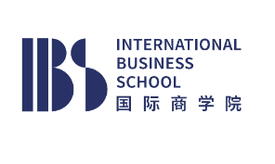

1. For the one-semester course, please prepare at least two Assessment Projects, including but not limited to: research paper, business plan or report, etc. This will be used for the evaluation of the students’ performance in the course. Please note that we may request you to help grade the students’ submission at your convenience and with extra stipend.
2. Essay Questions for the final evaluation, at least one question for each video hour. Please include the questions, the answers, and the evaluation standard. You may refer to the Attachment 2 for the sample of evaluation standard.

(We strongly recommend lecturers to design the *5 and *6 carefully, aimed at providing a stronger sense of interaction and improving the quality of video courses)

**TIPS** **OF RECORDING**

Recording with a ZOOM meeting is recommended, with the PowerPoint and the lecturer are both shown on the screen which can be very easily handled by most professors. Other online meeting platforms are acceptable, as long as meeting the above requirements. Please refer to the following sample screenshot. Demo video may be provided for reference on request.

Please use IBS.BFSU virtual background, which will be provided upon the approval of demo video.

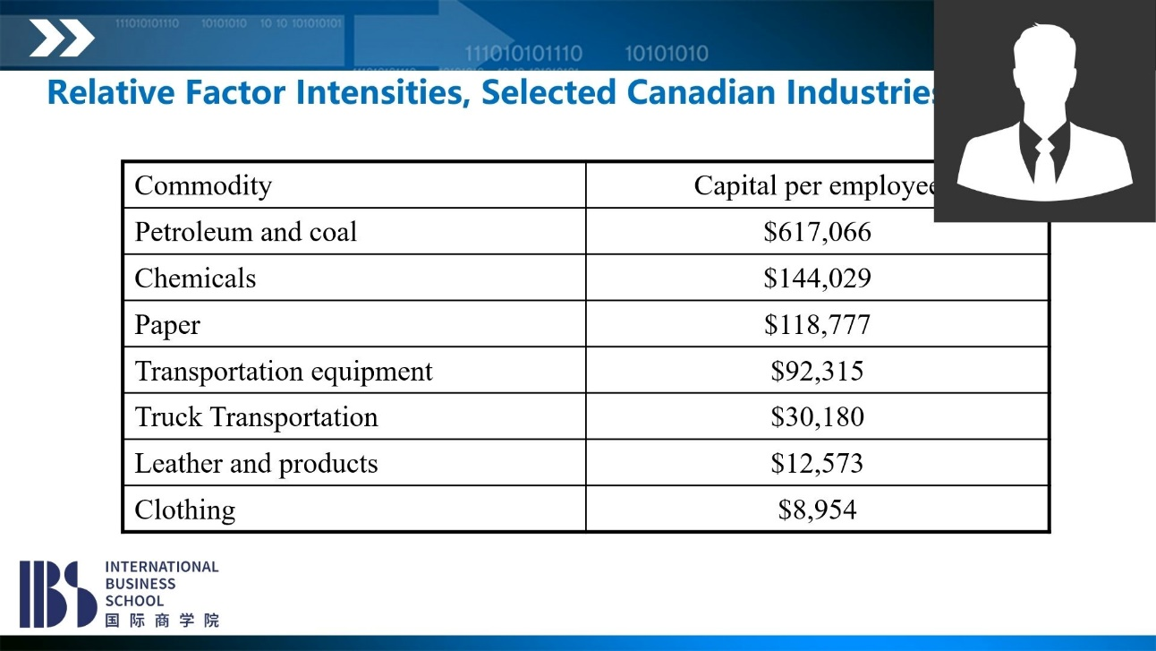

**FUNDING**

**One-time funding:**

CNY 10,000 pretax (around USD 1,500), for the regular course with 20~24 video hours and the materials required.

CNY 300-500 (USD 45-75) pretax, for each video hour, for the courses with less than 20 or more than 24 video hours, depending on the faculty qualification, course topic, and the quality of the video.

**Plus: Long-term Benefit**

**Course developers are very welcome to participate in the follow-up activities, including but not limited to coursework evaluation, interaction with the students (live lecture), etc. Extra stipend will be provided based on the working hours.**

1. 8% of the actual pay by registered students, with the amount exceeding the initial one-time funding.
2. Extra stipend of CNY 300-350 pretax for each working hour for the follow-up activities.

Please note that the course video and materials submitted must pass the review (for quality control purpose) by the Academic Committee of I-CEE center before the funding could be paid.

In order to make this payment to you, we will need a photocopy of your passport, and information for your bank account opened in mainland China. If you do not have a mainland China bank account, we could transfer it to your overseas bank account. Please note that this process may incur a fee to be borne by yourself. Under normal circumstances, this process should take about 1 month. However, with due consideration of possible administrative delays, the process may take up to 3 months. Once you receive the payment, please confirm your receipt with us by email.

**INTELLECTUAL PROPERTY RIGHTS**

1. It shall be the responsibility of the applicant to ensure that none of the graphics, animations, images, sound clips, video clips used are plagiarized or cited without formal permissions from owners.
2. All contents (text, audio, video, animation, quiz etc.) developed in this program will be the property of IBS.BFSU. The property rights referred to in this guideline shall mean the ownership of all contents and the right to use the contents. Course developers can continue to use the course contents for their own teaching, but are not allowed to authorize any other third-party institutions.

I-CEE Center

International Business School

Beijing Foreign Studies University

April 2022

**ATTACHMENT 1: Proposal for the Video Course**

|  |  |  |  |  |
| --- | --- | --- | --- | --- |
| **Passport Name:** |  | **Nationality:** | |  |
| **Institution:** |  | **Position/Title:** | |  |
| **Email:** |  | **Tel:** | |  |
| **Address** |  | | | |
| **Course list (please list the courses that you have been teaching during the past three years)**   |  |  |  |  | | --- | --- | --- | --- | | **University** | **Course Title** | **Target Students & Teaching Language** | **Course Type** (Please refer to the explanation below) | |  |  |  | 选择一项。 | |  |  |  | 选择一项。 | |  |  |  | 选择一项。 | |  |  |  | 选择一项。 | |  |  |  | 选择一项。 | | | | | |
| **Proposed Video Course:** | | | | |
|  | | | | |
| **Total Teaching Hours** | |  | | |
| **Target Students** | |  | | |
| **Course Type** | | 选择一项。 | | |
| **Course Introduction & Objectives** | | | | |
|  | | | | |
| **Textbook and Reference Materials** | | | | |
|  | | | | |
| **Course Outline** | | | | |
| Please list the detailed topics | | | Possible teaching hours of each topic | |
| **1**. **General Business Course** is a course listed as a core course in the curriculum of business school, designed for students who wish to obtain a breadth of knowledge in the fundamentals of business.  **2.** **Specialization Business Course** shall include business courses of specific areas set as independent courses, targeting junior, senior undergraduate and graduate students.  **3.** **International Business: Regional Topics** shall mean a course introducing business in the context of a target region or country. | | | | |

**\*Please submit your CV as an attachment.**

**ATTACHMENT 2: Sample of Essay Question Evaluation Standard**

**Question X:** A number of Latin American countries export coffee and import other goods. A long-term drought now reduces coffee production in the countries of this region. Assume that they remain exporters of coffee. (9 points)

1. Explain why the long-term drought in the region might lead to an increase in the region’s well-being or welfare. (3 points)

***Decrease in supply* - *World market prices rose*- 3 points**

b. What would make this gain in well-being more likely? (6 points)

**3 points for one key message, 6 points for two key messages**

***This is more likely if***

1. ***the growth is strongly biased toward producing more of the exportable product;***

***2) the country is heavily engaged in international trade;***

***3) supply is inelastic;***

***4) foreign demand for the country's exports is price inelastic.***